**GAME DESIGN DOCUMENT**

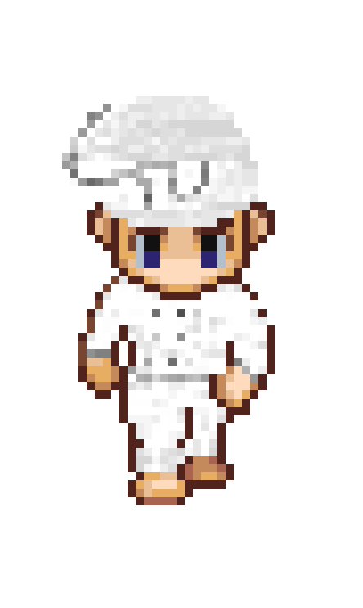

Pizza Game

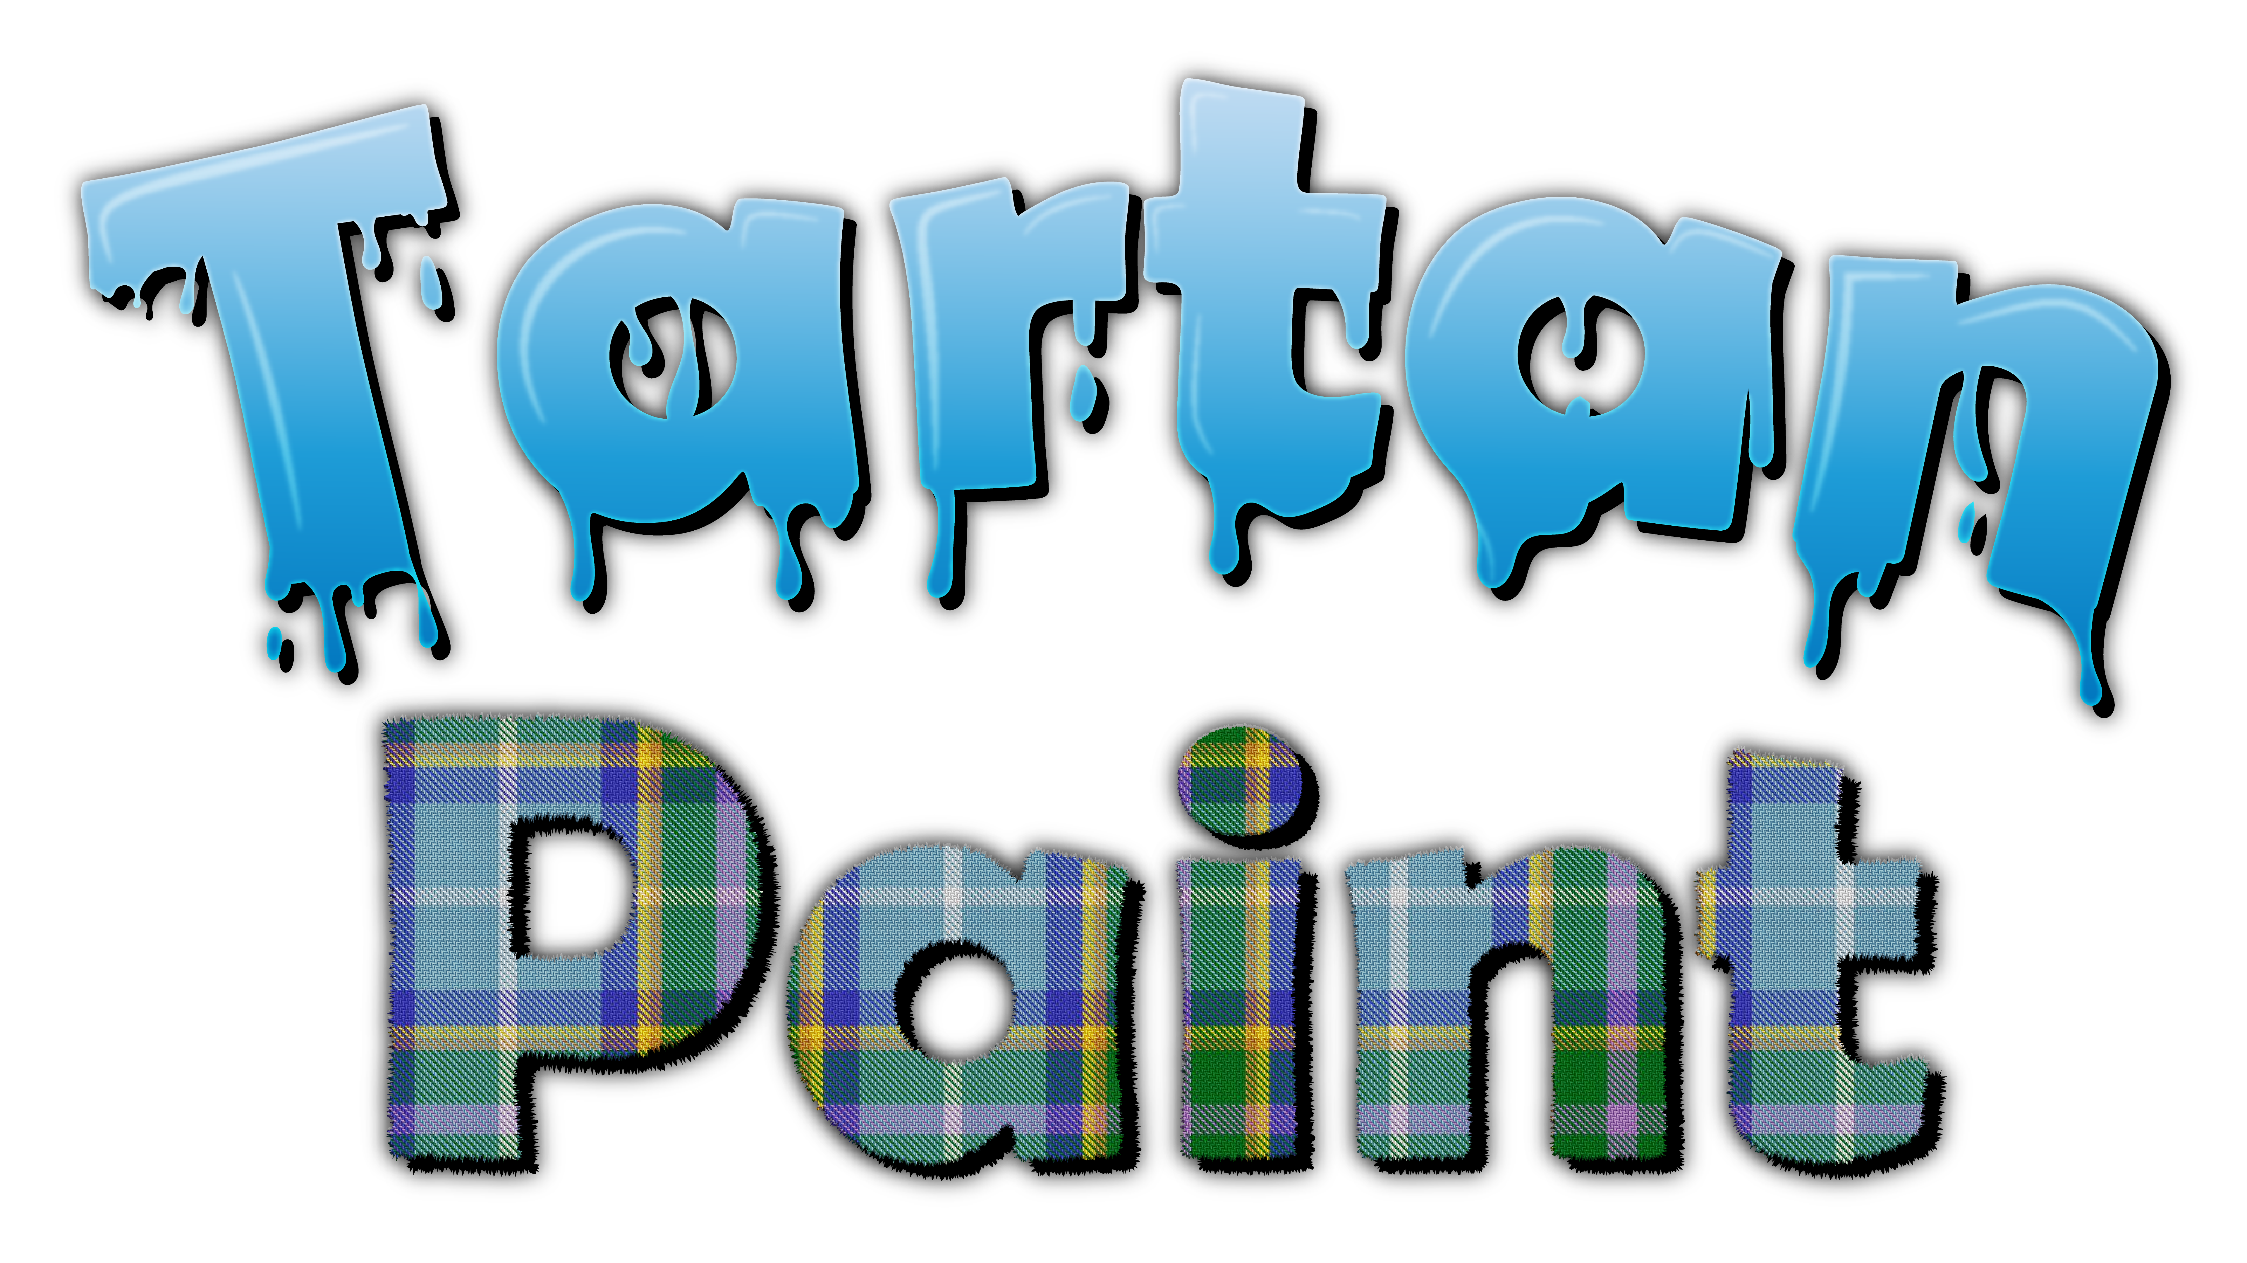

Tartan Paint Games Studio

**Last Updated:**

20/07/20

**Prepared By:**

Morgan Skillicorn

Producer

**TABLE OF CONTENTS**

Game Analysis 3

Mission Statement 3

Genre 3

Platforms 3

Target Audience 3

Storyline & Characters 4

Gameplay 5

Overview of Gameplay 5

Player Experience 5

Gameplay Guidelines 5

Game Objectives & Rewards 5

Gameplay Mechanics 5

Level Design 6

Control Scheme 7

Game Aesthetics & User Interface 7

Schedule & Tasks 8

# Game Analysis

Pizza Game is a top down RPG/Management sim where you run a pizza franchise and must conquer the city, taking down the competition and building a pizza monopoly. You worship Pizza Jesus and can pray to him at dedicated places of worship to add buffs and power ups to your character. As the game progresses you will be able to open new franchise locations across the city with their success resting on the pizza demand of the location as well as city taxes and delivery times. You can purchase new equipment to upgrade a restaurant and speed up its’ efficiency and capacity. You play the game as the franchise owner and must travel to the franchise locations in order to manage them in detail (some management can be done through our proprietary restaurant management system, OS).

# Mission Statement

Pizza Game is a top down RPG where you play as the franchisee of a pizza company. You must expand your empire and monopolize the pizza market while managing all aspects of your growing business. Product sourcing, distribution, manufacture, staffing and delivery are all parts of the puzzle that you must balance to create the fine-tuned machine that is a pizza empire.

# Genre

Tycoon game, management sim, RPG, world builder

# Platforms

PC

# Target Audience

Casual gamers that enjoy creativity and sandbox styled gameplay. While the game will include some elements of satire it should be suitable for a wide audience and not be limited to a mature audience.

# Storyline & Characters

The Franchisee begins the game after getting fired from a pizza store as a delivery driver. The walk down an alley and find the deeds to a pizza store. They then assume control and begin managing the franchise, driving it to success and monopolizing the cities pizza market.

|  |  |  |  |
| --- | --- | --- | --- |
| Character | Description | Characteristics | Misc. Info |
| The Franchisee | The player character. Finds the deed for a pizza shop at beginning of game and assumes ownership. They are the playable character from a third person top down view. | As the playable character, The Franchisee will differ game to game. The player will be able to customize their character at the beginning aesthetically and then buff them during gameplay by worshipping pizza Jesus. | Sprite will differ game to game.  Characters name will be set by the player. |
| The Health Inspector | A character that visits each restaurant on a certain date each month. | Random choice from aesthetic set. (In a specific suit) | When the character visits it will trigger a health check and if the players stats are too low the restaurant will be closed for a certain amount of time. |
| Corporate | A character that works for the company’s head office and inspects to check you are meeting the company’s goals. | Random choice from aesthetic set. (In a specific suit) | When the character visits it will check to see if the restaurant has met its monthly goals and if it has will award the restaurant with a bonus. If the store has made a loss then corporate will close the store. |
| Pizza Jesus | Pizza Jesus is your idol! You worship him and his holy dough. He provides you with skills and buffs to enhance your pizza shops! | Man looks like Jesus but wearing pizza toppings. | Lives in the pizza church and looks after the Holy Dough (A relic that provides buffs to the player) |
| Chef | Random seed generated character with different stats that affect characters ability to perform tasks. | Generic staff character that interacts with oven etc. | Characters stats are random, and their wage is more depending on levels. |
| Delivery Driver | Random seed generated character with different stats that affect characters ability to perform tasks. | Generic staff character that interacts with cars etc. | Characters stats are random, and their wage is more depending on levels. |
| Store Manager | Random seed generated character with different stats that affect characters ability to perform tasks. | Generic staff character that manage a store. | Characters stats are random, and their wage is more depending on levels. |
| Cashier | Random seed generated character with different stats that affect characters ability to perform tasks. | Generic staff character that interacts with till etc. | Characters stats are random, and their wage is more depending on levels. |

# Gameplay

## Overview of Gameplay

The game will be a hybrid genre. Primarily a management game but with a navigation system and style that gives it an RPG feel. The movement and camera positioning will be very similar to games like Pokémon. The city movement elements will be similar to games like the original GTA. The initial release will be for PC with the possibility for future ports to other consoles.  
  
The initial release will include a single player career mode as part of the first proof of concept. Once we have this mode working, we will be able to look at possible other game modes to add.  
  
At its’ core the game is a management sim but with a different spin on it. Rather than playing from a “god mode” view, you play as a character and must move around the world in a third person birds eye view. To manage properties in detail you must visit them. This means you must strategize your time to take best advantage.

## Player Experience

You begin your adventure wandering the streets of Flava Town after being fired from your job. You begin walking down a back alley and find a tattered scrap of paper. It is the deed to a run-down pizza shop on the outskirts of town. As you stop reading a tall and holy figure appears in front of you, Pizza Jesus. He tells you about the ancient prophesy and explains that you are the chosen one, The Franchisee. Your destiny is to thrive in Flava Town, ridding the world of substandard pizza and monopolizing the industry.  
  
The game takes place primarily in third person with you controlling your characters movements around Flava Town. When outside you will walk the streets and be able to visit other shops and restaurants. When needing to travel long distances you will be able to use a car. Traffic will path-find along a grid system when deliveries are in progress etc.  
  
When inside an establishment you will be able to walk around and check stock levels etc. as well as managing staff and upgrading equipment. A more minimal system to manage your shop is visible on the specialist PC running OS (Oregano System). This PC can be activated at any time and displays as a Windows inspired UI.  
  
You will be able to use your OS Laptop to transfer funds between each stores bank account as well as paying bills and managing finances. If you need a loan you will have to visit the bank in person when they are open.  
  
The game runs in a day and night cycle with certain shops only being open at certain times. You are responsible for managing your opening hours as well as staffs work schedules to ensure you are open to meet customers demand and are not wasting business resources during down time.

## Gameplay Guidelines

The game should be suitable for all ages; however, some level of adult humor will be present. At no point should the dialog or story of the game discriminate against anyone for any reason whatsoever (Pizza Jesus might need a new name).

## Game Objectives & Rewards

This is where you present more details on how the gameplay will motivate the player to progress through the game. Discuss rewards and penalties and the difficulty level. You can use the table below to help break down objectives and rewards.

|  |  |  |
| --- | --- | --- |
| Rewards | Penalties | Difficulty Levels |
| List ways of how the player is rewarded and when. | Discuss things that hinder the player on progressing | Discuss the difficulty levels within the game |

## Gameplay Mechanics

This is the where you start getting more specific on how some of the systems in the game will work. This includes how characters move in the game, what gameplay actions are available, item inventory and attributes, and how the game progresses from level to level.

|  |  |
| --- | --- |
| **Character Attributes** |  |
| **Character** | **Movement Abilities / Actions Available** |
| Name of character | List the characters abilities & how the player can perform them |
|  |  |
| **Game Modes** |  |
| Game Mode / Difficulty Name | Describe the objectives, hazards in the game mode. And discuss how the player progresses from level to level |
| **Scoring System** |  |
| **Points/Coins/Stars/Grades/Etc.** | **How it’s Awarded & Benefits** |
| List the scoring attribute | Describe how the player obtains this and the benefits. For instance, does getting more points unlock a special level. |

## Level Design

Discuss the levels. How many levels will the game have, what will be included in each level. Include overall look and feel, hazards the level presents, difficulty, objectives, etc.

|  |  |
| --- | --- |
| **Levels** |  |
| Level name and/or pic of it | List or describe the level’s look, difficulty, hazards, and objectives. |

# Control Scheme

Describe the control setup for the game. Does your game use touch input, a controller, or mouse & keyboard? Discuss the functionality of each button/touch. It may help to insert a diagram/pic to help explain the actions.

|  |  |
| --- | --- |
| **Button/ Touch Input** | **Action it Performs** |
| List the button | Describe what functionality the button press has within the game. |

# Game Aesthetics & User Interface

Discuss the design techniques to be used. Describe the look & shape of the characters, environment and pathways. Will the game look realistic or have some other art style. Discuss what type of theme the game will have & what type of emotional impact you are hoping players experience. Discuss how the player’s gestures/interactivity has an affect on the visual experience.

Present a general overview of the UI. How will the buttons be laid out, how will the HUD work, how does the menu system function, and so on. It is a good idea to insert photos, diagrams or concept art to help explain the UI.

# Schedule & Tasks

List the tasks that need to be completed along with the basic timeline to complete them by. The task list can be as detailed as you like to fit your studio’s needs. The table below can be substituted for the excel file. This table is a great start but the tasks should be much more detailed.

|  |  |  |  |  |
| --- | --- | --- | --- | --- |
| **Tasks to Complete & Schedule** | | | | |
| **Tasks** | **Task Lead** | **Start** | **End** | **% Complete** |
| **Development Phase** | | | | |
| Design |  |  |  |  |
| Storyline | John Doe | 9/4/15 | 9/8/15 | 0 % |
| Level Mechanics |  |  |  |  |
| Art |  |  |  |  |
| Level 1 |  |  |  |  |
| Special FX |  |  |  |  |
| UI |  |  |  |  |
| Engineering |  |  |  |  |
| Production Pipeline |  |  |  |  |
| Prototypes |  |  |  |  |
| Audio |  |  |  |  |
| Sound Design |  |  |  |  |
| Milestone: GamePlay Features & Music |  |  |  |  |
| **Testing Phase** | | | | |
| Test Plan |  |  |  |  |
| Beta Testing |  |  |  |  |
| Milestone: QA Testing |  |  |  |  |
| **Deploying Phase** |  |  |  |  |
| "Go Live" Plans |  |  |  |  |
| Milestone: Ready for Usage |  |  |  |  |